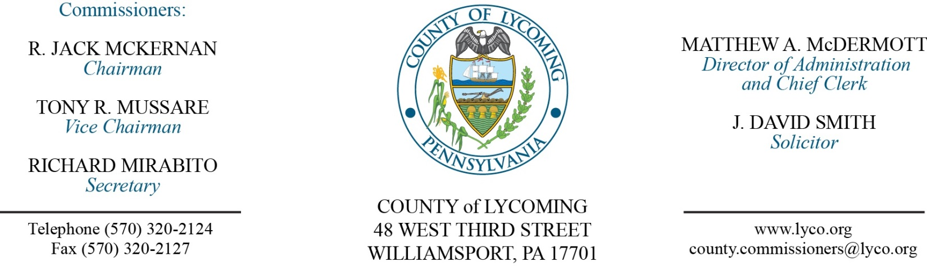
Commissioners’ Meeting Agenda
October 13, 2016

Opening Prayer

Pledge to the Flag

1.0 OPERATIONS

1.1 Convene Commissioners’ meeting.

1.2 Approve the minutes of the previous meetings.

1.3 Receive public comments (agenda items only).

2.0 ACTION ITEMS

2.1 Proclaim October as Domestic Violence month in Lycoming County. (Judge McCoy)

2.2 Approve professional service agreement with Maximus, Inc. in the amount of $3,000 for one year. (Beth Johnston)

2.3 Approve memorandum of understanding with Branch Drug & Alcohol for Act 198 in the amount of $30,000. (Mya Toon)

2.4 Approve memorandum of understanding with Branch Drug & Alcohol for Act 198 in the amount of $44,000. (Mya Toon)

2.5 Approve memorandum of understanding with Branch Drug & Alcohol for Act 198 in the amount of $15,000. (Mya Toon)

2.6 Approve professional service agreement with Dynamic Imaging Systems. (Mya Toon)

2.7 Approve professional service agreement with Glick Associates, Inc. for RMS. (Mya Toon)

2.8 Approve subrecipient agreement with STEP for 2015 PHARE. (Kim Wheeler)

2.9 Approve agreement with STEP for 2014 PHARE for homes in need program. (Kim Wheeler)

2.10 Approve personnel action: (Roxanne Grieco)
Prison – promotion of Craig L. Robbins as full time replacement Prison Maintenance Manager – Pay grade 10 - $63,109.70/annually effective 12/18/16.

Recess Commissioners’ Meeting

4.0 BOARD of ASSESSMENT REVISION

4.1 Convene Board of Assessment Revision.

4.2 Approve real estate refund for Donald & Anna Yohn parcel 35-005-119 in the amount of $210.80.

4.3 Approve real estate exonerations:
Parcel 02-001-126 Flick Properties 693 Rt 15 Hwy $44,200 to $21,800.
Parcel 02-001-127 Flick Properties 709 Rt 15 Hwy $152,630 to $12,260.

4.3 Adjourn Board of Assessment Revision.

Reconvene Commissioners’ Meeting

5.0 REPORTS/INFORMATION ITEMS

5.1 Lycoming County is requesting quotes for Professional Land Surveyor Services. (Fran McJunkin)

5.2 Request bids for Bunker Sand and Gravel for WDGC. (Mya Toon)

5.3 Request bids for Bunker Renovation at WDGC (2nd request). (Mya Toon)

5.4 Zoning Hearing Board vacancies 12/31/16.

6.0 COMMISSIONER COMMENT:

7.0 PUBLIC COMMENT:

8.0 NEXT REGULARLY SCHEDULED MEETING: Planning Session on Tuesday, October 18, 2016.

9.0 ADJOURN COMMISSIONERS’ MEETING.

